The 2023 Pitch Clock Rule And Local Crime Patterns
Group 5
Clinton Burns, Emma Hockett, Aswathy Chandrasekar, Mohammad Mohibur Rahman, Sneha Ranjeet Sonaye, Shreyash Sanjay Agrawal, Shreyam Misra, Sai Chandra Vuddamari

Introduction
Our research question is whether the MLB pitch clock rule changes, by shortening game duration, caused an increase in crime in blocks surrounding Dodger Stadium during game hours and those immediately following.
Klick & MacDonald (2021) show that reducing the amount of MLB game time between the end of alcohol sales and the end of the game correlated to an increased crime rate following the game. Beginning with its 2023 season, Major League Baseball implemented a new pitch clock rule that reduced the average duration of its games by twenty-four minutes. We analyze whether this reduction in game duration – and reduction in game time following the cessation of alcohol sales - resulted in an increase in crimes.
This question is of interest to policymakers both in local and regional governments, as well as those leading sports and entertainment venues and franchises. Cities, for example, often pass regulations such as curfews to limit crime in their jurisdictions. Understanding what, if any, effect the duration of baseball games has on crimes will inform their decisions as to how to staff security and police, as well as policy decisions regarding timing of events.

Literature Review
In the most similar example, Klick and MacDonald (2021) found that decreasing the time between last alcohol sales and the end of a baseball game was associated with an increase in crime after the game in adjacent areas. The MLB pitch clock rule decreased the time between the last alcohol sales and the end of the game, suggesting it may also result in a similar increase in crime.
Other studies have examined how large sporting events affect crime in the areas surrounding stadiums. Mares and Blackburn (2019) found the MLB games in St. Louis increase crime within walking distance from the stadium. Marie (2016) found that professional football matches in London were associated with increased crime rates near stadiums. Campadelli (2024) found spikes in crime rates associated with events at the arena in Newark. Together, these studies demonstrate that local crime often responds to crowd size and event timing related to in-person sporting events.
Additional research has analyzed how sporting events affect crime at the city or regional level. Laquer and Copus (2015) found that televised sporting events reduce crime in Chicago. Kalist and Lee (2016) demonstrate that NFL home games increase specific types of crime in the home cities. These studies show that crime rates can respond to sporting events based on the context, such as game location and whether viewing is in-person or televised.
Together, the research shows that alcohol access and timing of sporting events and the associated crowds can influence nearby crime rates and patterns.
However, no study has examined the reduced game duration created by MLB’s pitch clock rule. By comparing crime around Dodger Stadium before and after the implementation of the rule, this study provides new evidence on how alcohol consumption windows at sporting events affect crime.

Data

Datasets
This analysis used Los Angeles Police Department crime data, US Census blocks, Retrosheet MLB schedules, and NOAA weather data.
The dataset Los Angeles Police Department Crime Data From 2020 to Present contained observations describing crimes reported in Los Angeles County including the latitude and longitude where committed, the timestamp of when the crime occurred, and the type of crime committed. This dataset ultimately provided the dependent variable – the count of crimes.
The dataset 2020 TIGER / Line Shapefiles provided the census blocks for the state of California used for the most recent US census. These blocks define granular geographic segments within cities. This dataset was used to identify blocks within the treatment and control radii and to map crime observations to them.
The datasets Retrosheet Game Logs 2022 and 2023 contained observations describing an individual MLB game played during the 2022 and 2023 seasons including the date, time, duration, location, teams, attendance, and game outcomes.
The dataset Global Hourly – Integrated Surface Database provided detailed weather information for the USC ISD station in Los Angeles for 2022 and 2023. The variables included wind, temperature, precipitation, and sky.

Data Preprocessing
The datasets were filtered to include only observations for the years 2022 and 2023, the immediate season pre- and post-pitch clock rule. Variables deemed redundant or irrelevant for modeling were dropped.
Events were broken into the date and the hour, rounded down. For example, a crime committed at 08:37 was assigned an hour value of 8. Partial hours were handled in the same manner for game start and end times and weather reports. Events such as games spanning multiple hours resulted into multiple records, one per hour.
The game data was filtered for Los Angeles Dodger home games; the weather for the nearby USC ISD weather station; and the census blocks for those adjacent to the stadium (<700 meters) or a control group (<1600 meters) using polygon distance. This configuration provided 30 treatment blocks and 241 control blocks indicated by the binary variable “adjacent”.
Crimes were mapped to census blocks using latitude and longitude, a spatial join, and the California Albers CRS. Only those mapped to an adjacent or control census block were retained. Crime counts were aggregated at the day-hour-block granularity.
The datasets were joined into a single set with day-hour-block granularity. Time zones were standardized to Pacific Standard Time prior to joins. We imputed zero crime counts for block-hours with no matching crime data (i.e., an implied zero crime count), and the game hour flag was set to false for block-hours not matching a game data record.
The “post_rule_change” binary variable was created to indicate if the date fell after the pitch clock rule change.
As noted below, we ran some versions of models using a day-block granularity due to the sparsity of crimes committed. The dataset was identical to the hourly version except for dropping of the hour feature.
Name | Mean | SD | Min | Max
crime_count | 0.001 | 0. 036 | 0 | 13
adjacent | 0.11 | 0.31 | 0 | 1
is_game_hour | 0.0335 | 0.18 | 0 | 1
attendance | 1596.3 | 8614.5 | 0 | 53432
Wind | 6.55 | 10.3 | 0 | 77
Temperature | 21.29 | 57.596 | 1.7 | 999.9
Precipitation | 0.211 | 2.04 | 0 | 58

Name | Definition | Source
crime_count | Count of crimes reported | LAPD
adjacent | Binary indicator of whether the census block is within 700 meters of the stadium | Constructed
post_rule_change | Binary indicator of whether the day is before (0) or after (1) the MLB rule change | Constructed
is_game_hour | Binary indicator of whether the day and hour are during or immediately following an LA Dodgers home game | Retrosheet
block_id | US census block identifier | US Census Bureau
date | The calendar date | Constructed
hour | The hour of the day represented as an integer (0-23) | Constructed
dow_hour | The day of the week and hour | Constructed
attendance | The number of attendants at the game | Retrosheet
Wind | The wind speed in meters per second | NOAA
Visibility | Sky visibility | NOAA
Temperature | Temperature in degrees Celsius | NOAA
Precipitation | Amount of precipitation in millimeters | NOAA

Empirical Methods

Economic Model
Large sporting events such as MLB games can influence nearby crime by increasing foot and vehicle traffic, the concentration of intoxicated persons, and shifting police and security resource allocations. Prior research has shown that shorter no-alcohol intervals before fans leave the stadium can increase the prevalence of crime near the venue (Klick & MacDonald, 2021). The MLB pitch clock rule reduced the average game duration by twenty-four minutes, resulting in a shortened time between last call and stadium exit. While the mechanism is different, this reduction may increase crime during or immediately after games.
We modeled crime in each census block as a function of its distance to the stadium, whether the pitch clock rule is in effect, whether the hour occurs during a Los Angeles Dodgers home game, and time-varying conditions that affect crowd size or behavior.
We specify the economic model:
$${Crime}_{b,t}=f({Adjacent}_{b},{Post}_{t},{GameHour}_{t},Interactions,{Attendance}_{t},{Weather}_{t},μ_{b},λ_{t})$$
where:
${Crime}_{b,t}$ is the number of crimes in block b during hour t
${Adjacent}_{b}$ is 1 if block b is within 700 meters of the stadium
${Post}_{t}$ is 1 if t occurs after the implementation of the MLB pitch clock rule
${GameHour}_{t}$ is 1 if t corresponds to an hour during an LA Dodgers home game
${Attendance}_{t}$ is the attendance for the MLB game at time t
${Weather}_{t}$ is the set of ${Wind}_{t}, {Visibility}_{t}, {Temperature}_{t}, {Precipitation}_{t}$ at the USC meteorological station in Los Angeles at time t
$μ_{b}$ are the time-invariant block fixed effects
$λ_{t}$ are the date-hour specific factors affecting all blocks
The function represents the production of crime with block- and time-specific factors. It mirrors the hypothesis that the pitch clock rule influences crime through changes to game duration.

Econometric Model

Ordinary Least Squares (OLS)
Our primary econometric model estimates the effect of the pitch clock rule on crime using a triple-differences (DDD) framework.
$${Crime}_{b,t}=β_{0}+β_{3}{GameHour}_{t}+β_{5}\left({Adjacent}_{b}×{GameHour}_{t}\right)+β_{6}\left({Post}_{t}×{GameHour}_{t}\right)+β_{7}\left({Adjacent}_{b}×{Post}_{t}×{GameHour}_{t}\right)+γ_{1}{Attendance}_{t}+γ_{2}{Wind}_{t}+γ_{3}{Visibility}_{t}+γ_{4}{Temperature}_{t}+γ_{5}{Precipitation}_{t}+μ_{b}+λ_{t}+ε_{b,t}$$
Because block fixed effects absorb all time-invariant variables, including adjacency, and date fixed effects absorb all intra-day shocks, the main effects of ${Adjacent}_{b}$, ${Post}_{t}$, and their interaction are not separately identified. Only terms that vary within a block within a day are estimable.
The coefficient of interest is $β_{7}$, which captures the differential change in crime during game hours in adjacent blocks after the 2023 pitch clock rule change. Standard errors are clustered at the block level to allow for serial correlation within blocks.

Poisson Pseudo-Maximum Likelihood (PPML)
Because the dependent variable is a non-negative count and sparse at the hourly level, we chose to also include a Poisson pseudo-maximum likelihood (PPML) model. To reduce sparsity, we aggregated the crime count to a block-day level.
The conditional mean of crime is:
$${E[Crime}_{b,t}|X_{b,t},μ_{b},λ_{t}]=exp⁡(β_{5}\left({Adjacent}_{b}×{GameDay}_{t}\right)+β_{6}\left({Post}_{t}×{GameDay}_{t}\right)+β_{7}\left({Adjacent}_{b}×{Post}_{t}×{GameDay}_{t}\right)+γ_{1}{Attendance}_{t}+γ_{2}{Wind}_{t}+γ_{3}{Visibility}_{t}+γ_{4}{Temperature}_{t}+γ_{5}{Precipitation}_{t}+μ_{b}+λ_{t})$$
Because the PPML model includes block and date fixed effects, terms that vary only at the block (${Adjacent}_{b}$) or the date (${Post}_{t}$, ${GameDay}_{t}$) level are fully absorbed and cannot be separately identified. Therefore, those main effects and their interactions that do not vary within both dimensions do not appear in the estimating function.
This function accommodates heteroskedasticity and does not require the variance to equal the mean. Standard errors are clustered at the block level.

Identification Strategy
To identify the causal effect of the MLB pitch clock rule change, we use a triple differences (DDD) approach with three sources of variation: whether a census block is adjacent to Dodger Stadium; whether the observation occurs after the MLB pitch clock rule implementation; and whether the observation takes place while a game is taking place or immediately after. The coefficient on the triple interaction ${Adjacent}_{b}×{Post}_{t}×{GameHour}_{t}$ captures the post-treatment change in game-hour crime within blocks near the stadium.
The approach assumes that, had the pitch clock rule not been implemented, adjacent and control blocks would have parallel trends in crime rates during non-game hours. It further assumes, that the difference in crime rates between game and non-game hours would have changed similarly across blocks. And finally, it assumes that no other shock to crime rates in 2023 affected adjacent blocks during game hours in particular.
To evaluate the plausibility of these assumptions, we investigated crime trends in the treatment and control blocks for the time prior to implementation of the pitch clock rule. First, we looked at crime rates for non-game hours and found very similar weekly trends, supporting the first assumption.
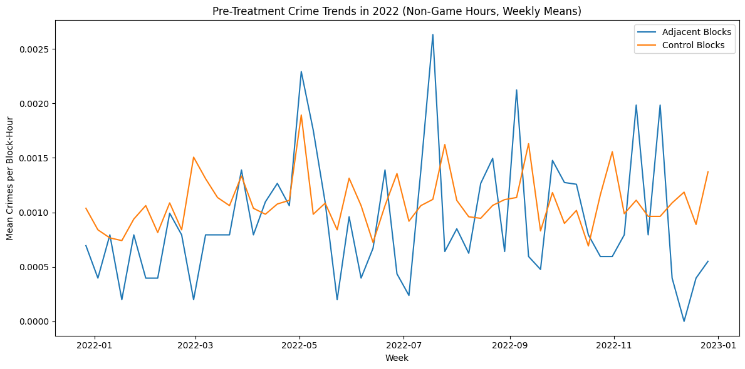
Next, we looked at pre-treatment crime rates for game hours. While the magnitude of adjacent blocks was greater than control blocks, there were no diverging trends. This supports the second assumption.
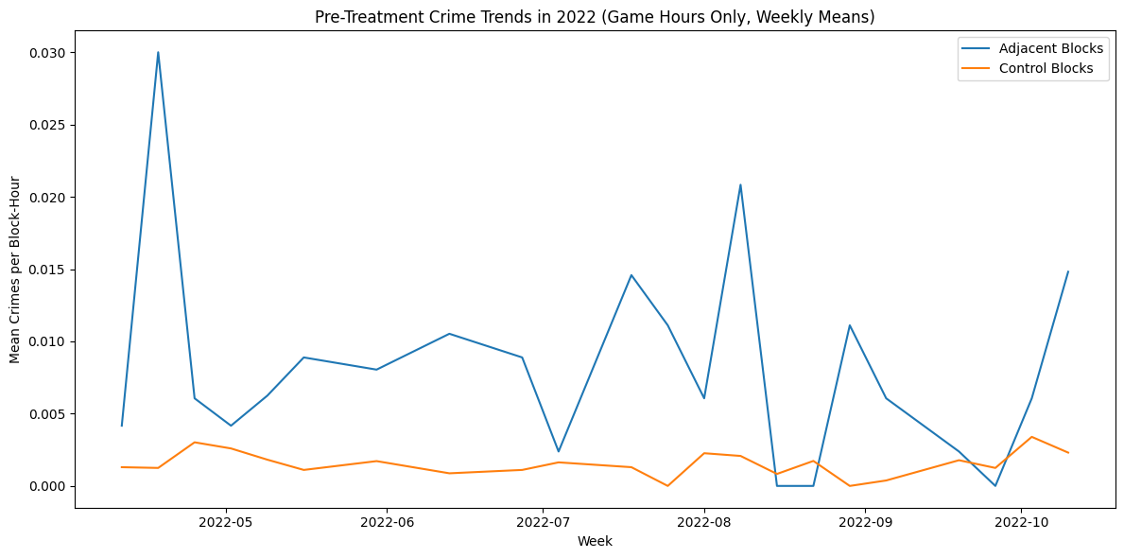
The timing of the MLB pitch clock rule implementation and the MLB schedule were both determined by the league with no considerations for the crime pattern around Dodger Stadium or any other venue. Weather is naturally exogenous. The predictors in general can reasonably be viewed as exogenous. Fixed effects for block and date help absorb confounding factors such as holidays.
The primary concerns of bias were related to spatial spillover effects and crime sparsity. To mitigate spillover effects, we used block fixed effects and defined control blocks with a limited radius. For the latter, we estimated models with both hourly and daily aggregations of crime counts.

Statistical Methods
We estimated the effect of the 2023 MLB pitch clock rule using OLS and PPML models with block and time fixed effects. Both models rely on variation in the triple interaction ${Adjacent}_{b}×{Post}_{t}×{GameHour}_{t}$, and we used cluster-robust standard errors at the block level.
The primary coefficient of interest is the triple interaction coefficient $β_{7}$. Our null hypothesis is no change in game-hour crime in adjacent blocks after the rule change:
$$H_{0}: β_{7}=0$$
Our alternative hypothesis is an increase in game-hour crime in adjacent blocks after the rule change:
$$H_{1}: β_{7}>0$$

OLS Assumptions
The consistency of the OLS estimator with fixed-effects requires the standard assumptions for panel data. The model is defined to be linear in its parameters.
Our model assumes strict exogeneity – the error term must be uncorrelated with predictors in all time periods. This is plausible because MLB scheduling and the pitch clock rule are determined independently of block-level crime, and weather is naturally exogenous. While attendance might respond to long-term crime trends, we used date fixed effects that should account for those shifts.
In the model as specified, the adjacent predictor is time-invariant and therefore is collinear with the block fixed effects. When fitting the model, adjacency and its interaction with post_rule_change were dropped by the software as expected. However, its other interaction terms that vary within blocks and dates remained.
Crime data exhibit heteroskedasticity and within-block serial correlation, so we are reporting cluster-robust standard errors at the block level, which allows for dependence within blocks over time.

PPML Assumptions
PPML requires that the conditional mean of the outcome be specified as:
$$E\left[Y_{b,t}|X\right]=exp(X_{b,t}β+μ_{b}+λ_{t})$$
This assumption is required for consistency and is weaker than the assumptions regarding distribution required by the traditional Poisson model. The variance is not required to equal the mean and is more flexible regarding heteroskedasticity. This makes it a fit for sparse count data such as the crime counts in our dataset.
PPML requires the same assumptions as OLS for two-period panel data analysis for strict exogeneity, no perfect collinearity, and independence of errors across blocks, which were discussed in the OLS section above.
The use of fixed effects accounts for effects common to all blocks or that do not vary over time. These, along with controls such as weather and attendance, reduce concerns regarding omitted-variable bias.
Our model provided sufficient within-block variation in the regressors such as days, times, and weather conditions.

Results

OLS
We found that the coefficient of the interaction term for the causal effect was positive, which was expected, with a coefficient of 9.494420e-07. Given the sparsity of crimes committed, a small coefficient was not surprising; however, it is not economically substantive.
The coefficient was not statistically significant. The two-sided p-value was 0.998 (t=0.002); the one-sided p-value was 0.499. Therefore, we fail to reject the null hypothesis of no change in game-hour crime in adjacent blocks after the rule change.

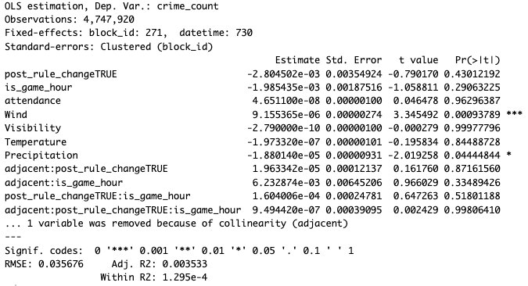

Poisson
The coefficient for the interaction term was positive at 0.25, indicating a 28.4% increase in crimes committed per day in adjacent blocks on game days after the rule change relative the control groups.
However, the result is not statistically significant at the 5% threshold. The one-sided p-value is only 0.064 (two-sided 0.128). Therefore, we fail to reject the null hypothesis of no change in game-hour crime in adjacent blocks after the rule change. While not conventionally significant, it is close enough to suggest further study.
The pseudo-R^2 for the PPML model (0.1386) was significantly higher than for OLS (0.0035), indicating it explains more of the variance in the conditional mean of crime counts. However, the two measures are not directly comparable as a measure of goodness of fit.

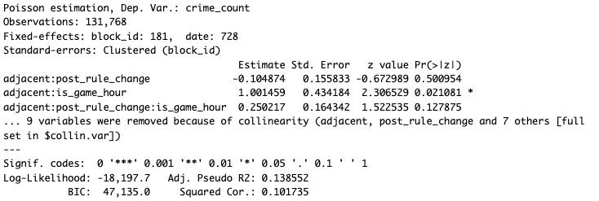

Conclusion
We investigated whether the MLB pitch clock rule implemented for the 2023 season increased crime in the blocks adjacent to the stadium during and immediately following home games. Using a triple-differences identification strategy with OLS and PPML models, we compared crime rates across adjacent and control blocks, before and after the rule change, and during game and non-game hours.
The estimated treatment effect was positive, but not statistically significant. The OLS model produced an extremely small coefficient that was not economically meaningful. The PPML model coefficient suggested a potentially larger percentage increase. However, in both cases, the result was not statistically significant, and we could not reject the null hypothesis of no change in crime following the rule change.
While no causal effect can be supported, the results do suggest that additional research with different methods or data could provide more insight.

References
Laqueur, H. F., & Copus, C. K. (2015). Entertainment as crime prevention: Evidence from Chicago sports games. Unpublished manuscript. SSRN. https://papers.ssrn.com/sol3/papers.cfm?abstract_id=2429551
Kalist, D. E., & Lee, D. Y. (2016). The impact of professional football games on crime. Applied Economics Letters, 23(13), 930–933. https://ideas.repec.org/a/sae/jospec/v17y2016i8p863-882.htm
Billings, S. B., & Depken, C. A. II. (2012). Sporting events and criminal activity: Evidence from micro-level data. Journal of Sports Economics, 13(5), 523–545. https://www.researchgate.net/publication/226197336_Sport_Events_and_Criminal_Activity_A_Spatial_Analysis
Mares, D., & Blackburn, E. (2019). Major League Baseball games and neighborhood crime: Evidence from St. Louis. Deviant Behavior, 40(11), 1413–1432. https://www.tandfonline.com/doi/full/10.1080/01639625.2025.2540923
Marie, O. (2016). Police and thieves in the stadium: Measuring the (multiple) effects of football matches on crime. Journal of the Royal Statistical Society: Series A, 179(1), 273–294. https://www.jstor.org/stable/43965805
Klick, J., & MacDonald, J. (2021). Sobering up: The impact of game length and alcohol sales on postgame crime. American Law and Economics Review, 23(2), 414–440. https://scholarship.law.upenn.edu/faculty_scholarship/2263/
Campedelli, G. M., et al. (2024). Event-induced crime patterns: Evidence from the Prudential Center in Newark, NJ. Crime Science, 13(1), Article 12. https://link.springer.com/article/10.1007/s11292-023-09576-8
Bowman, D. L. (2025). Unsportsmanlike behavior: Examining variation in arrests across professional sports events. Deviant Behavior. Advance online publication. https://www.tandfonline.com/doi/full/10.1080/01639625.2025.2540923

Contains 467,604 rows and 28 features
https://data.lacity.org/Public-Safety/Crime-Data-from-2020-to-Present/2nrs-mtv8/about_data)
https://www.census.gov/geographies/mapping-files/2020/geo/tiger-line-file.html
Contains 4,943 rows and 43 features
https://www.retrosheet.org/gamelogs/index.html
Contains 22,929 rows and 82 features
https://www.ncei.noaa.gov/products/land-based-station/integrated-surface-database
The final combined hour-level dataset included 4,747,920 records and 11 features. The day-level dataset included 197,830 records and 10 features

